Vignettes and Borders

Step 1: Convert The Background Layer Into A Smart Object
We'll start by converting the layer our photo is sitting on into a Smart Object. This way, the Camera Raw Filter will be applied as a Smart Filter, keeping the vignette effect itself fully editable while the original image remains untouched and unharmed. With my photo newly opened in Photoshop CC, if we look in the Layers panel, we see the image sitting on the Background layer:
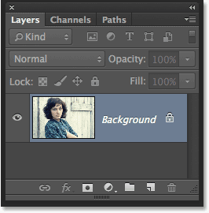
The Layers panel.
To convert the layer into a Smart Object, click on the small menu icon in the top right corner of the Layers panel:
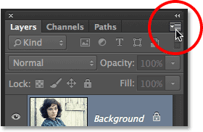
Clicking the Layers panel menu icon.
Choose Convert to Smart Object from the menu that appears:
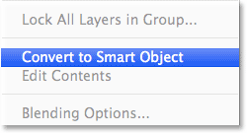
Choosing "Convert to Smart Object".
Nothing will seem to have happened to the image in the document window, but a small Smart Object icon appears in the lower right corner of the layer's preview thumbnail, letting us know that the layer is now a Smart Object:
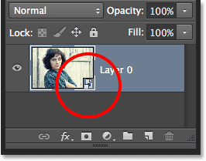
The layer preview thumbnail displaying the Smart Object icon.

Step 2: Select The Camera Raw Filter
Go up to the Filter menu in the Menu Bar along the top of the screen and choose Camera Raw Filter:
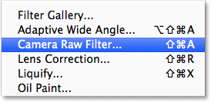
Going to Filter > Camera Raw Filter.
The image will appear inside the large Camera Raw dialog box. Technically, this is the Camera Raw Filter dialog box, but with few exceptions, all of the tools, controls and options that we'd find in the main Camera Raw dialog box are here:

Step 3: Select The Radial Filter
Along the top left of the Camera Raw dialog box is where we find its various tools. Click on the Radial Filter to select it (it's the last tool on the right):
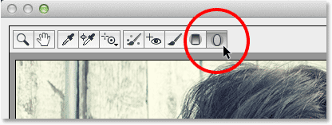
Choosing the Radial Filter.

Step 4: Lower The Exposure
With the Radial Filter selected, the panel on the right of the Camera Raw dialog box displays the Radial Filter's various options for making adjustments to the image. Start by clicking the round minus icon ( - ) directly to the left of the word Exposure. This will set the Exposure slider to a preset value of -50, but the main reason we're doing this is because it instantly resets all of the other sliders to 0, allowing us to focus just on the Exposure setting:
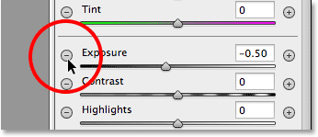
Clicking the minus icon to the left of the Exposure slider.
Then, click on the Exposure slider itself and drag it further to the left to a value of around -2.00. This will give us a good initial darkening value to start with. The image itself won't appear any darker at the moment because we haven't yet added the actual filter, but we'll do that next:
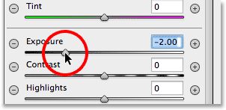
Setting the initial Exposure value to -2.00.

Step 5: Drag Out The Radial Filter In The Image
With the Exposure value lowered, click somewhere near the center of where you want your vignette effect to appear in the image. Then, with your mouse button still held down, drag outward from that point. You'll see the elliptical Radial Filter shape appearing as an outline as you drag (if you want to force the Radial Filter shape into a perfect circle, press and hold the Shift key on your keyboard as you're dragging). You can move the filter shape around inside the image as you're dragging it by pressing and holding the Spacebar on your keyboard. Release the Spacebar once you've positioned the filter where you want it to continue dragging out its shape, then release your mouse button when you're done:
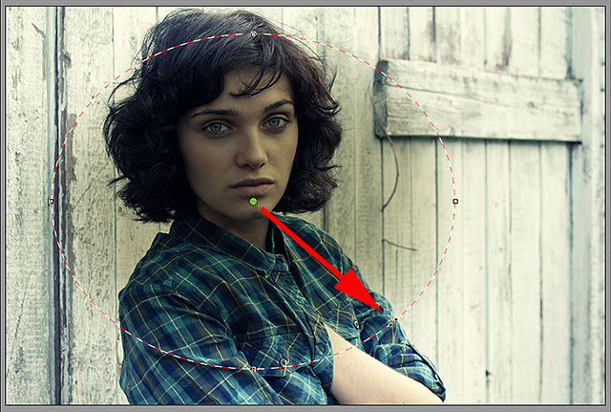
Dragging out the Radial Filter from its center.

The Outside / Inside Effect Option
Notice, though, that with my image, the inside of the Radial Filter shape is being darkened while the area outside the shape remains at its original brightness level. That's the exact opposite of what I wanted for my vignette effect. If you're seeing the same thing with your image, look down at the bottom of the Radial Filter options in the panel along the right (you may need to scroll down using the scroll bar along the right of the panel if you're not in Camera Raw's Fullscreen mode). There, at the bottom of the list, is an option called Effect with two checkboxes that control where the image adjustments are applied - inside the shape or outside. Mine is currently set to Inside so I'll click the Outside option to change it:
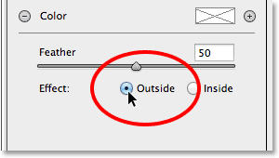

Resizing, Moving And Rotating The Shape
Once you've dragged out your initial Radial Filter shape, you can resize and reshape it, making it taller, shorter, wider or more narrow, by clicking and dragging any of the four handles (the little squares). You'll find one at the top, bottom, left and right of the shape. You can continue moving the shape around inside the image if needed by moving your mouse cursor inside the shape. When your cursor changes to a four-pointed direction arrow, click and drag your mouse. Also, you can rotate it by moving your mouse cursor near the edge of the shape, then clicking and dragging when you see your cursor change into a curved, double-pointed arrow. In my case, I'm just going to make my shape larger by clicking and dragging the handles:
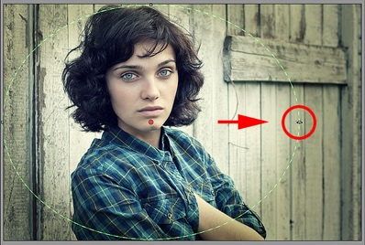
Dragging a handle to resize and reshape the filter.

Step 6: Adjust The Image Using The Sliders
Now that we've added the filter to the image, we can use the various image adjustment sliders in the panel along the right to make further changes to the effect.
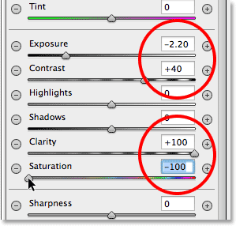
Changing the look of the image using the various adjustment sliders.

Adjusting The Feathering
We can also adjust the feathering amount for the vignette, or in other words, increase or decrease the size of the transition area between the main image in the center and the darker area surrounding it, by dragging the Feather slider left (to decrease it) or right (to increase it). You'll find the Feather slider near the bottom of the options on the right (directly above the Outside / Inside Effect option):
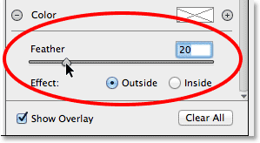
Adjusting the size of the transition area with the Feather slider.

Showing And Hiding The Overlay
To get a better view of what your vignette effect looks like, you can temporarily hide the Radial Filter overlay in the preview area by unchecking the Show Overlay option in the lower right of the Camera Raw dialog box. Select the option again to turn the overlay back on. Or, you can quickly turn the overlay on and off simply by pressing the letter V on your keyboard. Here, I'm unchecking the option to turn the overlay off:
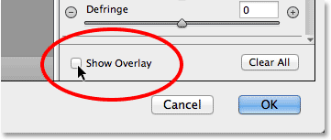
Unchecking the Show Overlay option.

Turning the overlay off makes the effect easier to see.

Step 7: Add A Second Radial Filter
One of the most powerful features of Camera Raw's Radial Filter is that we can add additional Radial Filters to the same image, each with separate image adjustments! To add a new Radial Filter, select New at the top of the Radial Filter panel:
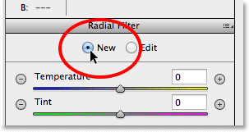
Selecting the New option.
Then, just use everything we've learned from adding our initial filter to add the second one. First, click inside the image and drag outward to create the new filter shape, holding down your Spacebar as you drag to reposition it if needed:
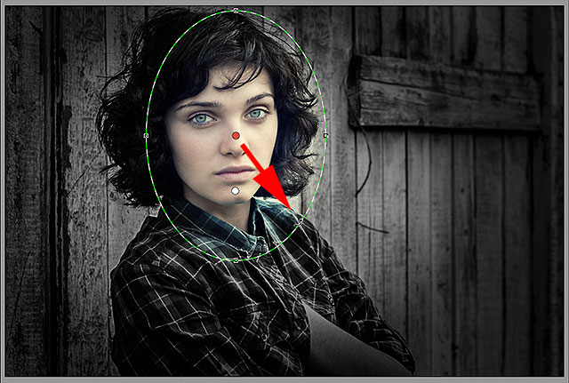
Clicking and dragging out a second Radial Filter.

Switching Between Radial Filters
Notice that there are now two round dots on my screen. Each dot represents one of the filters. At any time, we can switch between filters to re-adjust their settings simply by clicking on their dots. The currently active filter will have a colored dot while the other dot(s) appear white. Here, I've clicked on the initial filter's dot to re-select it and make it active:

Switching back to the original filter by clicking its dot.
I'll switch back to my new filter by clicking on its dot. Notice that a couple of things are happening with this second filter. First, all of my settings from the initial Radial Filter have been copied to this second filter. We'll change that in a moment, but the second thing to notice is that my effect is again being applied outside the shape. With this second filter, I want the effect to appear inside the shape, so once again, I'll scroll down to the bottom of the Radial Filter panel along the right and switch the Effect option from Outside to Inside. Or, I could just press the letter X on my keyboard to instantly switch from Outside to Inside and vice versa:
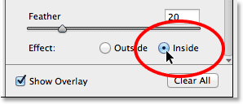
Changing the Effect option from Outside to Inside.
And now, the effect appears inside the second filter. Notice also that the filter's selection dot has changed from red to green. A red dot means the effect is being applied outside the shape, while a green dot indicates it's being applied inside:

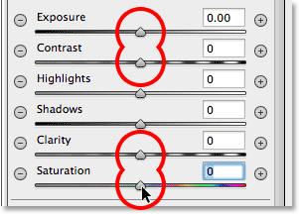
Double-clicking sliders to reset them.
Now that my second filter has been reset, this time I'll start by cooling down the overall color temperature inside the shape by dragging the Temperature slider at the top of the panel a little to the left. A value of around -20 will add a slight blue color cast. I'll leave the Tint slider directly below it set to 0 since I don't want to add any green or magenta to the image. I'll also leave the Exposure slider set to 0, but I'll increase the Contrast to +50. Again, these are just settings that I've found, after some experimenting, that they work well with this particular image.
I'll dial down the highlights, bringing out a bit more detail in the lightest areas inside the shape, by lowering the Highlights value to around -25. Then I'll do the opposite with the Shadows slider, increasing it to +25 to brighten up some of the darkest areas, again bringing out more detail. I'll bump the Clarity value up to +50 to bring out more contrast in the midtones, and finally, I'll lower the Saturation value to -30 to reduce the color saturation:

Step 8: Close Out Of The Camera Raw Dialog Box
I'm happy with my effect, so I'll click the OK button in the lower right corner of the dialog box to accept my settings and close out of the Camera Raw Filter:
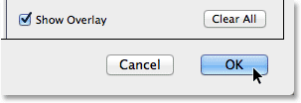
Clicking the OK button.
If we look again in the Layers panel in Photoshop itself, we now see the Camera Raw Filter listed as a Smart Filter below the image. I'll click on the Smart Filters visibility icon to temporarily hide the effects of the Camera Raw Filter from view in the document window:
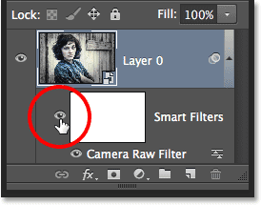
Clicking the OK button.
This hides all of the changes I made with the Radial Filter and re-displays the original image. Notice that it remains untouched and unaffected by anything we've done:

The original image re-appears unharmed.
I'll click again on the Smart Filter visibility icon to turn the Camera Raw Filter back on, and now we see the final Radial Filter vignette effect:

